Café Grill Menu
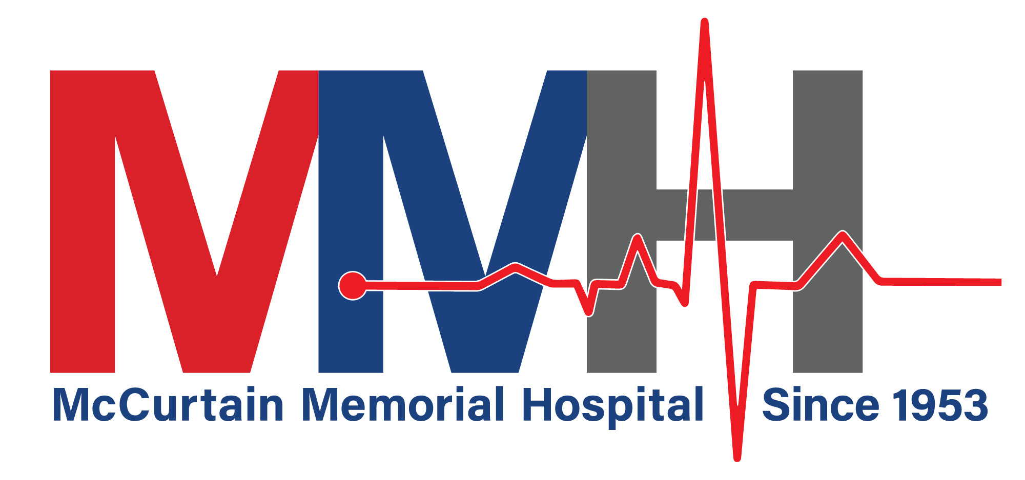

Quesadilla (Beef or Chicken) w/Bell Peppers, Onions, (You may add Mushrooms)

Sour Cream and Picante

Chicken Crispitos (2)

w/Sour Cream and Picante

Chicken Tender Dinner w/Side, Gravy & Toast

Steak Finger Dinner

w/Side, Gravy & Toast

Fried Liver Dinner

w/Side, Gravy & Toast

Gizzard Dinner w/Side, Gravy & Toast

MMH Café Hours
Monday through Friday
Open to the Public
Breakfast Buffet
6:30AM to 9:00AM
$6 per meal​
Lunch Line
11:30 AM to 1:00 PM
$6 per meal​

Hamburger

Bacon Cheeseburger

Mushroom Swiss Burger

BLT

Club Sandwich (Turkey or Ham)

Grilled Ham & Cheese

Grilled Cheese

Patty Melt (Grilled Onion & Swiss)

Hot & Spicy Chicken Sandwich

Crispy or Grilled Chicken Toaster

Fried Bologna Sandwich

Sides Include:

French Fries

Sweet Potato

Tator Tots

Onion Rings

Bread:

Wheat

Wheat Berry

White

Texas Toast

CALL-IN ORDERS TO
(580) 208-3185
Ext. 185

