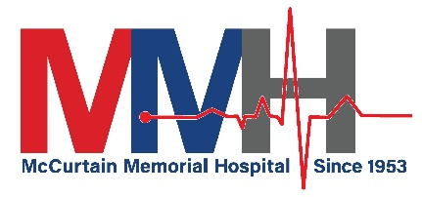
Current MMH Fax Numbers
Medsurg: | (580)208-3285
OB: | (580)208-3390
Lab: | (580)208-3264
Surgery: | (580)208-3353
Respiratory: | (580)208-3282
Radiology: | (580)208-3265
Physical Therapy: | (580)789-4806
Pharmacy: | (580)208-3276
Medical Records: | (580)208-3254
ED: | (580)208-3395
Echo: | (580)786-2364
Dietary: | (580)208-3280
Central Supply: | (580)208-3274
Business Office: | (580)208-3193
Admissions: | (580)208-3284
Administration: | (580)208-3199
Medical Staff Services | (580)208-3160
RHC Idabel | (580)286-8287
RHC Hochatown | (580)494-6566
RHC Valliant | (580)933-9304

